1) MRE

AM 1.5 [All_var]

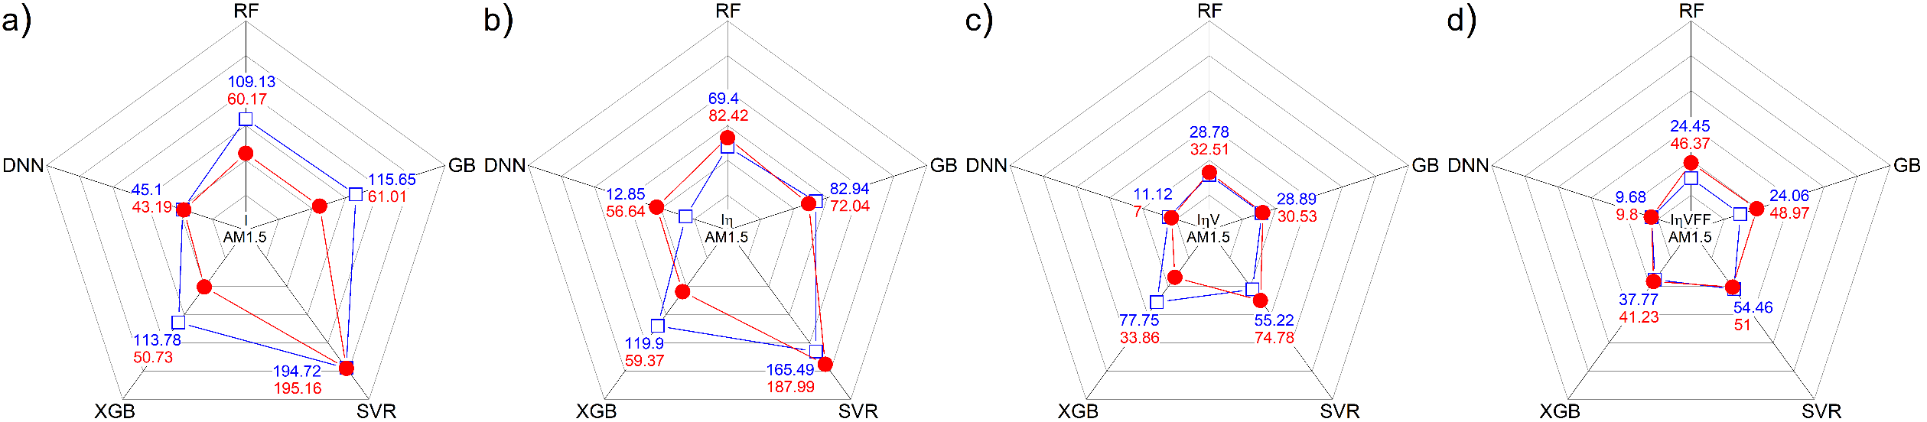

940 nm [All_var]

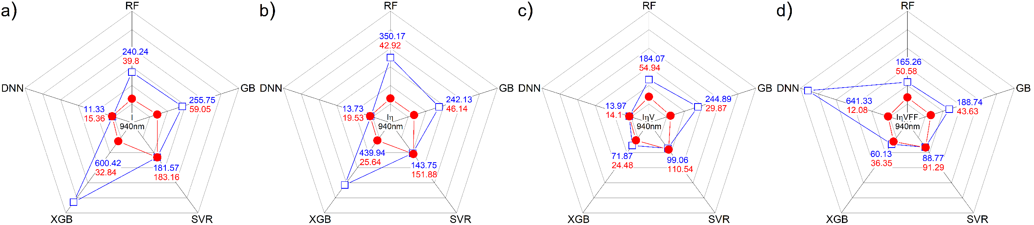

AM 1.5 [B_var]

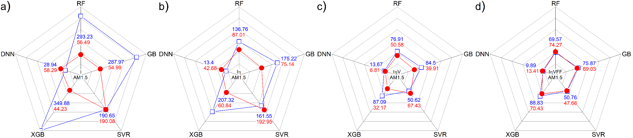

940 nm [B_var]

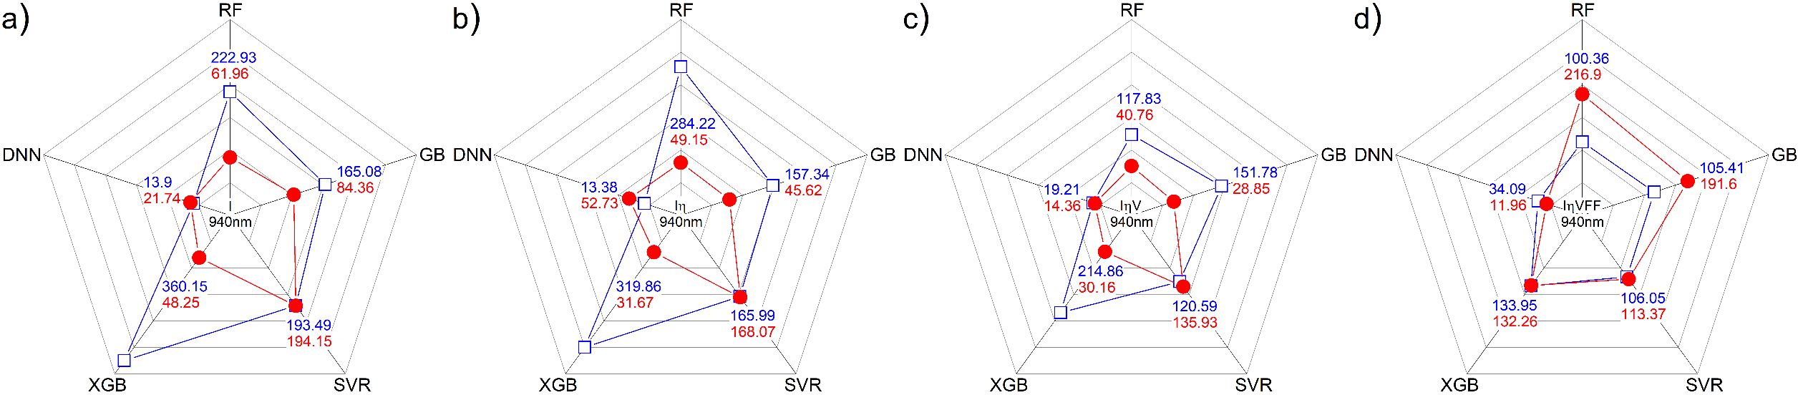

AM 1.5 [Fe_var]

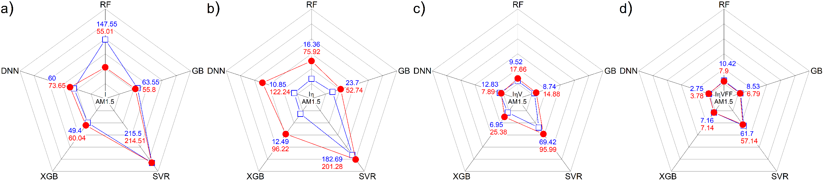

940 nm [Fe_var]

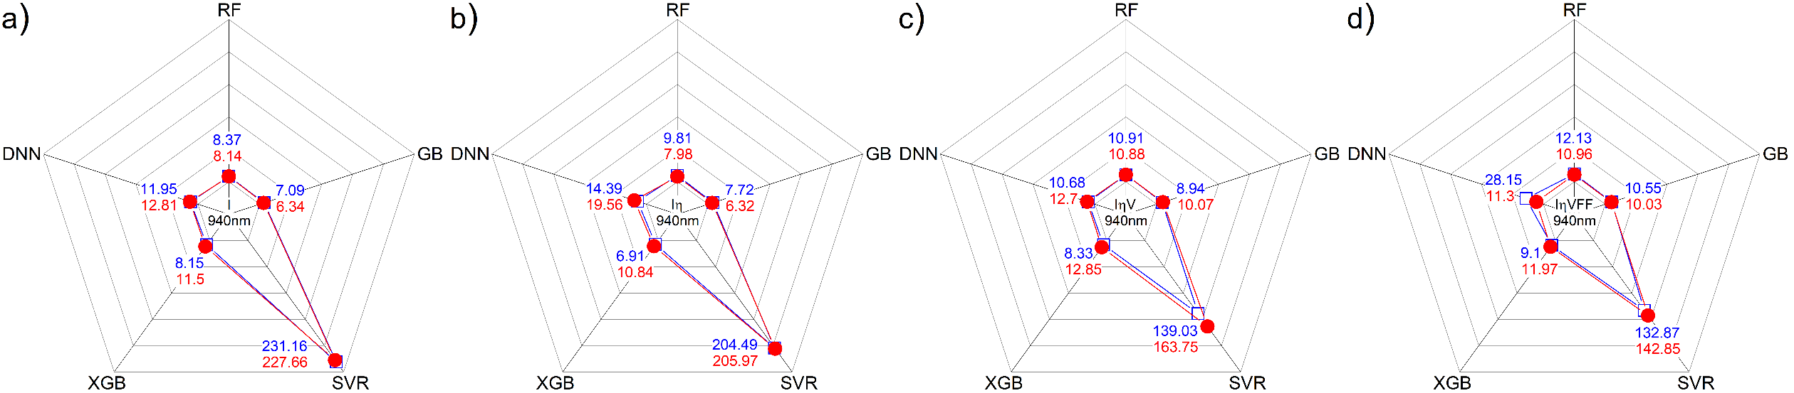

AM 1.5 [Full]

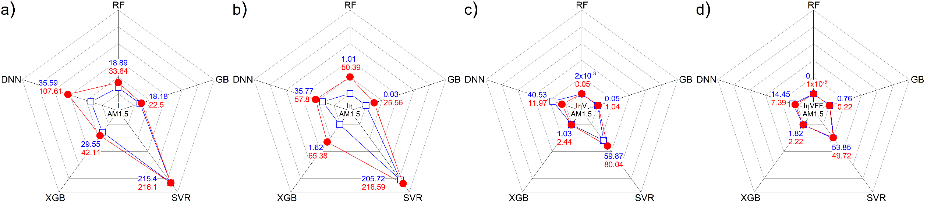

940 nm [Full]

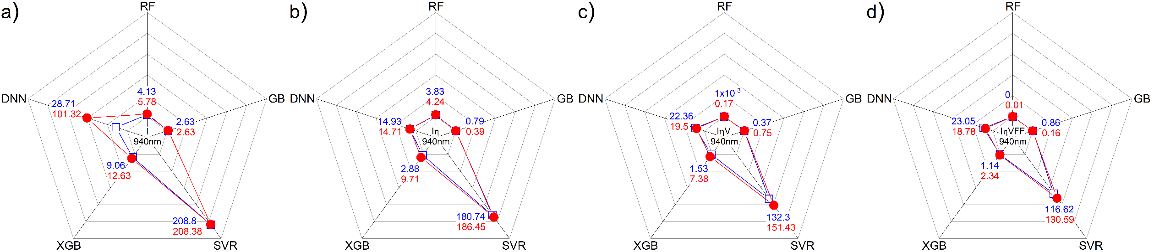

AM 1.5 [T_var]

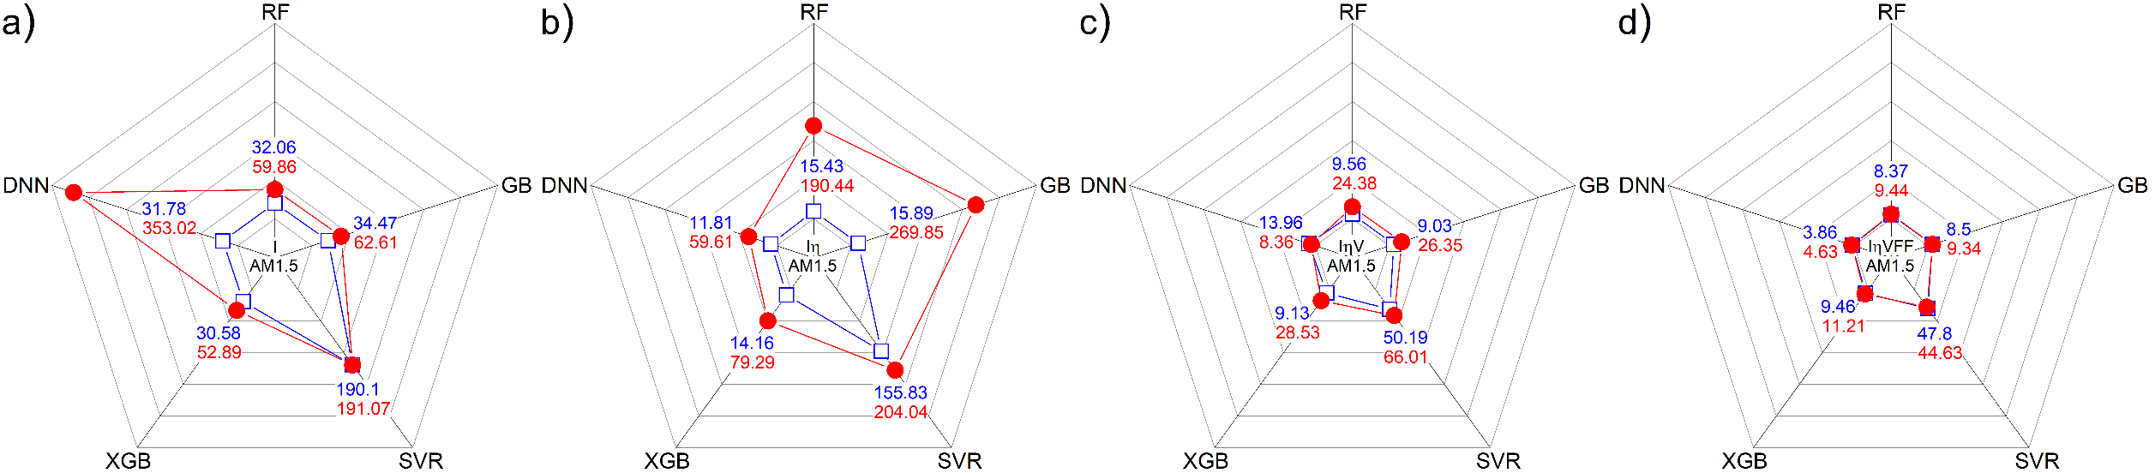

940 nm [T_var]

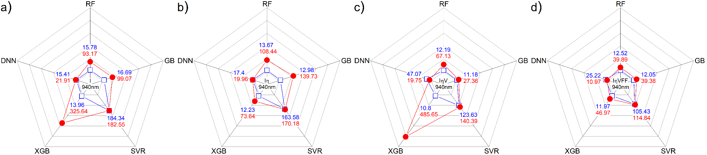

AM 1.5 [Train]

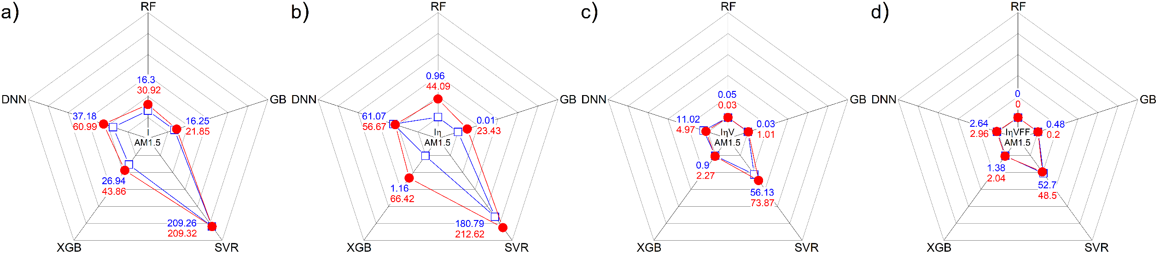

940 nm [Train]

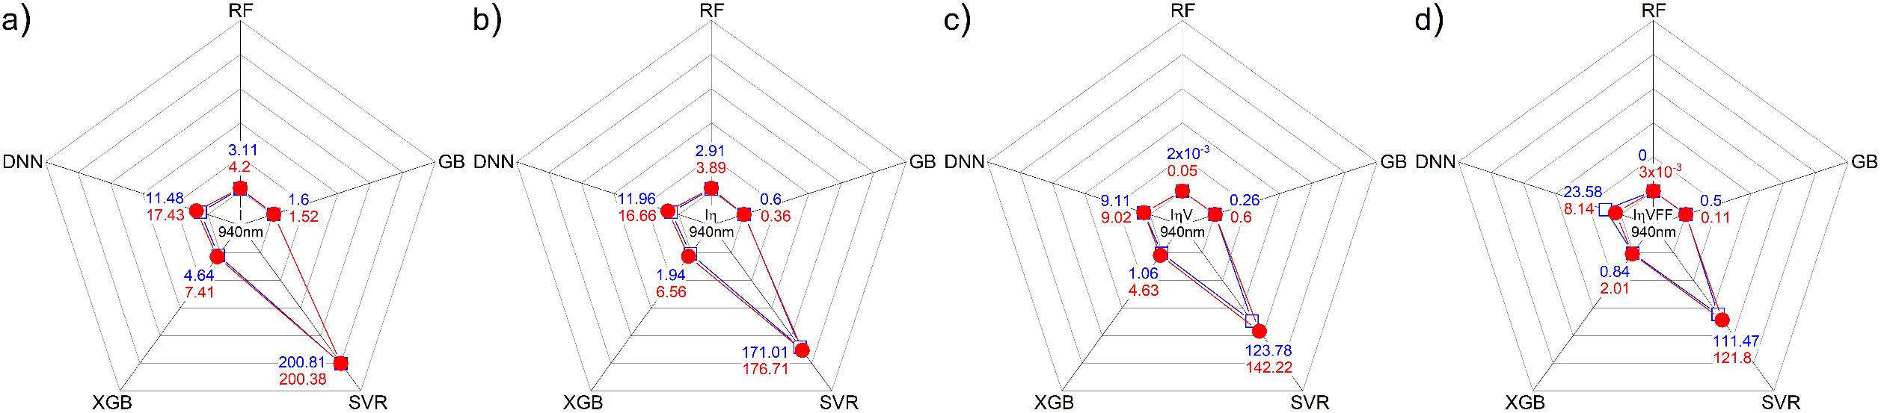

2) MSE

AM 1.5 [All_var]

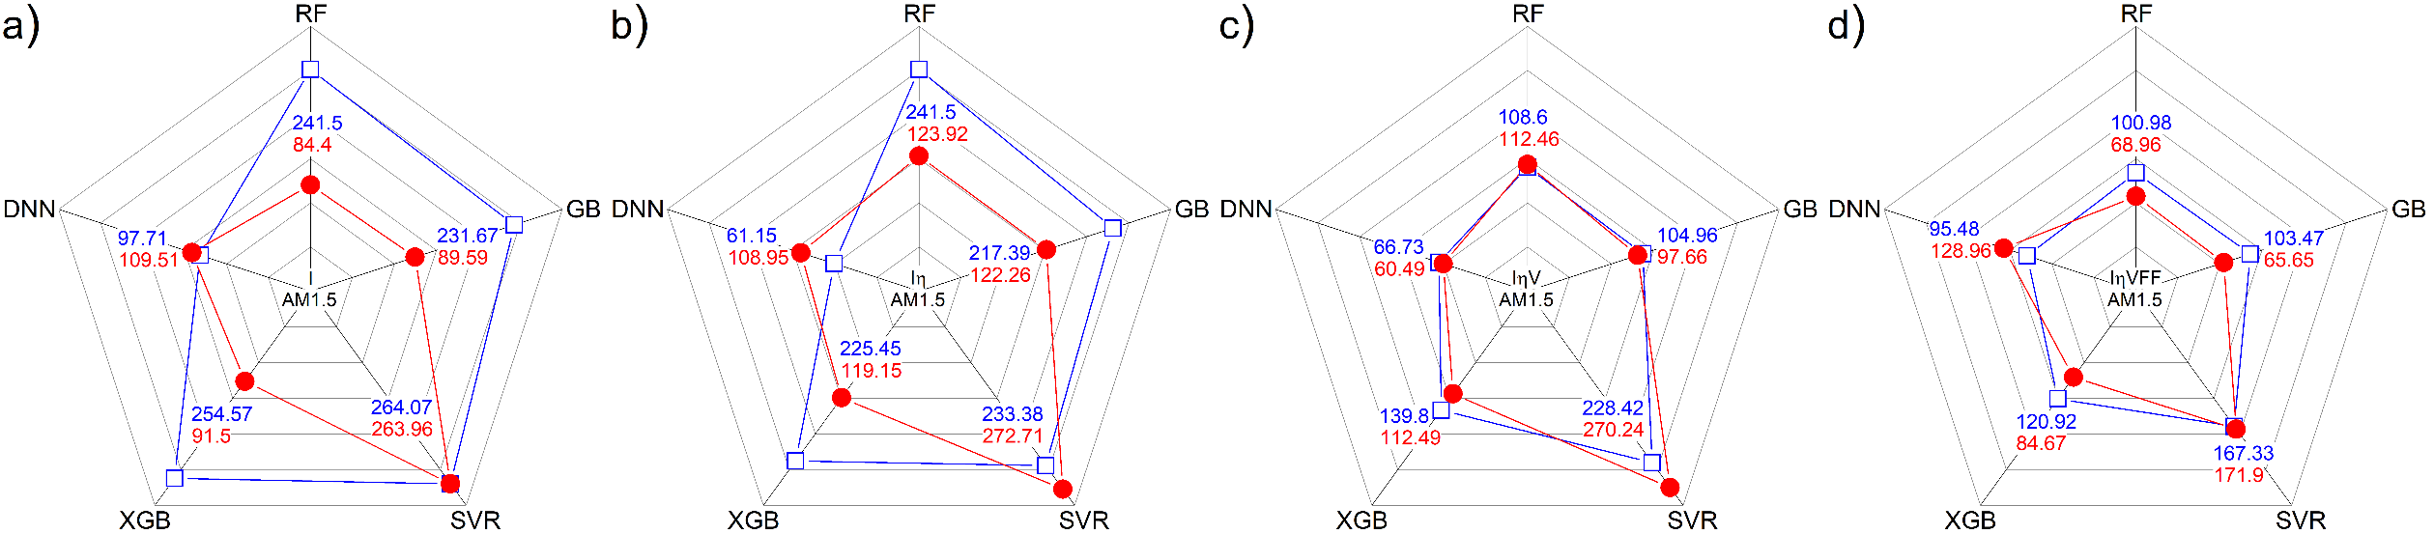

940 nm [All_var]

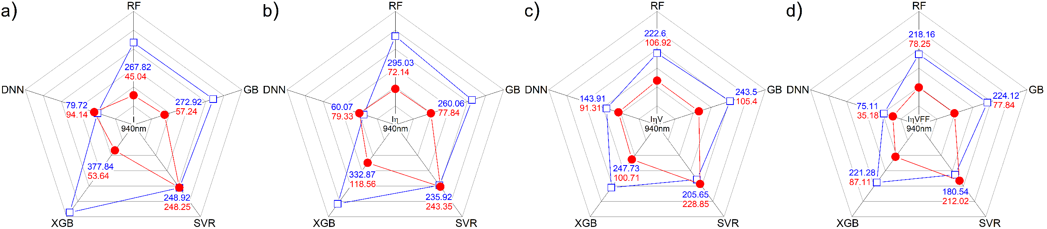

AM 1.5 [B_var]

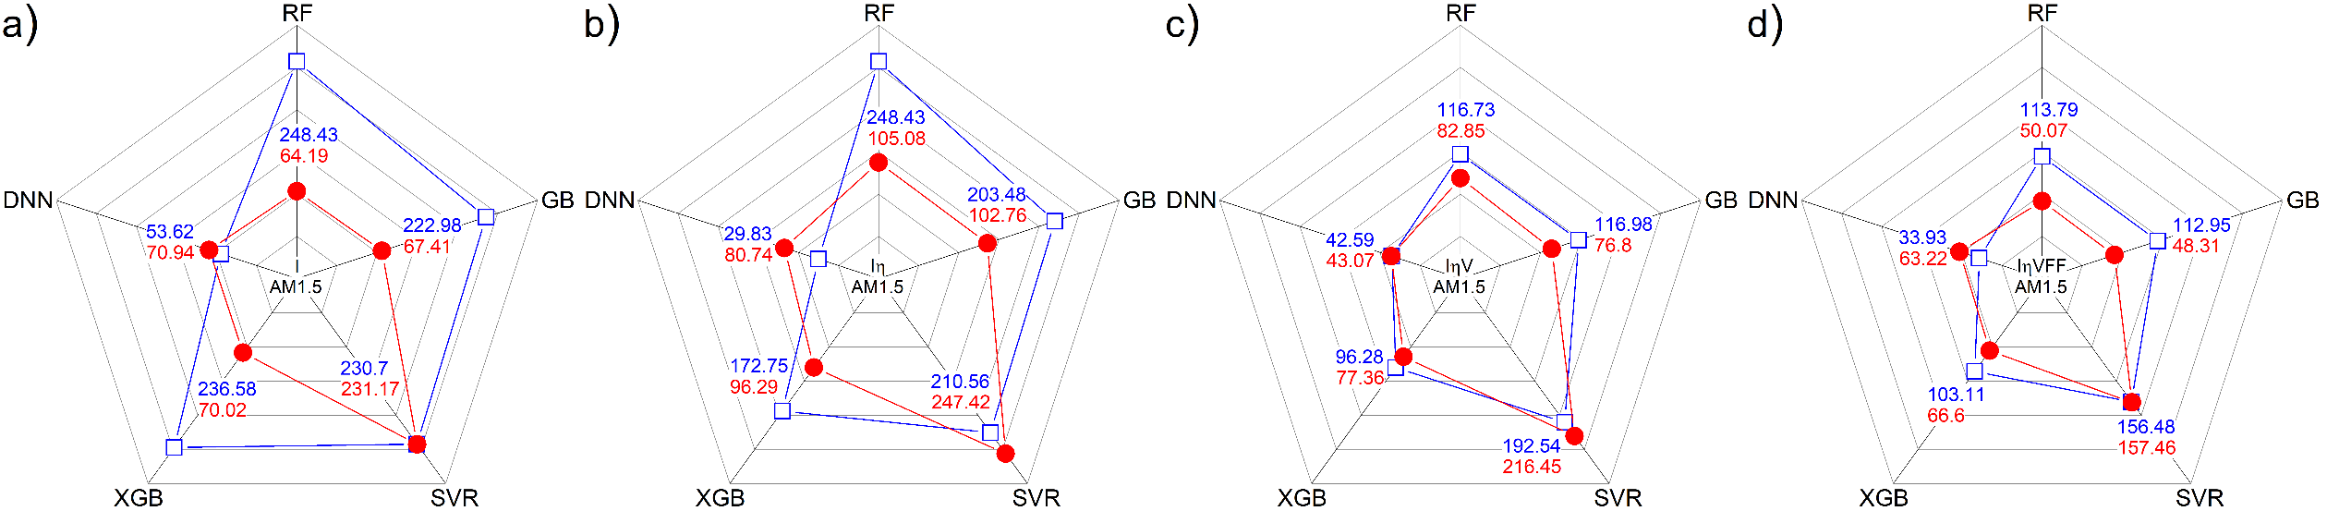

940 nm [B_var]

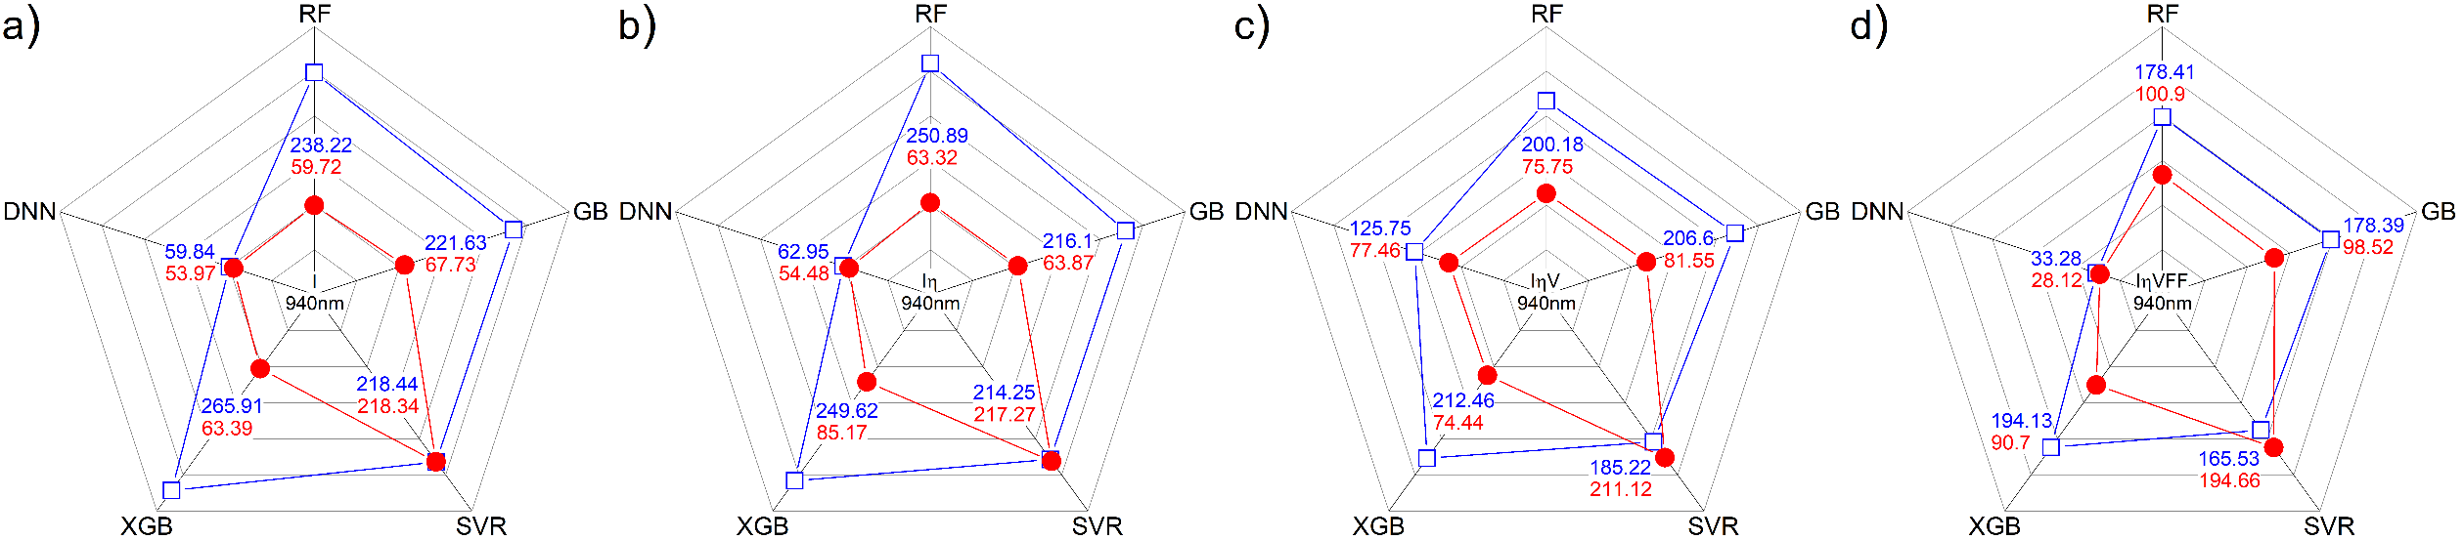

AM 1.5 [Fe_var]

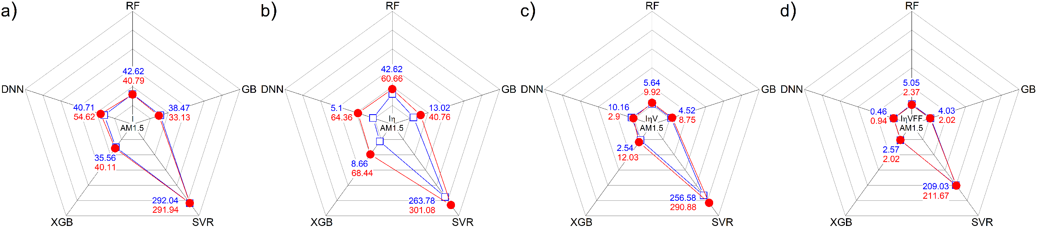

940 nm [Fe_var]

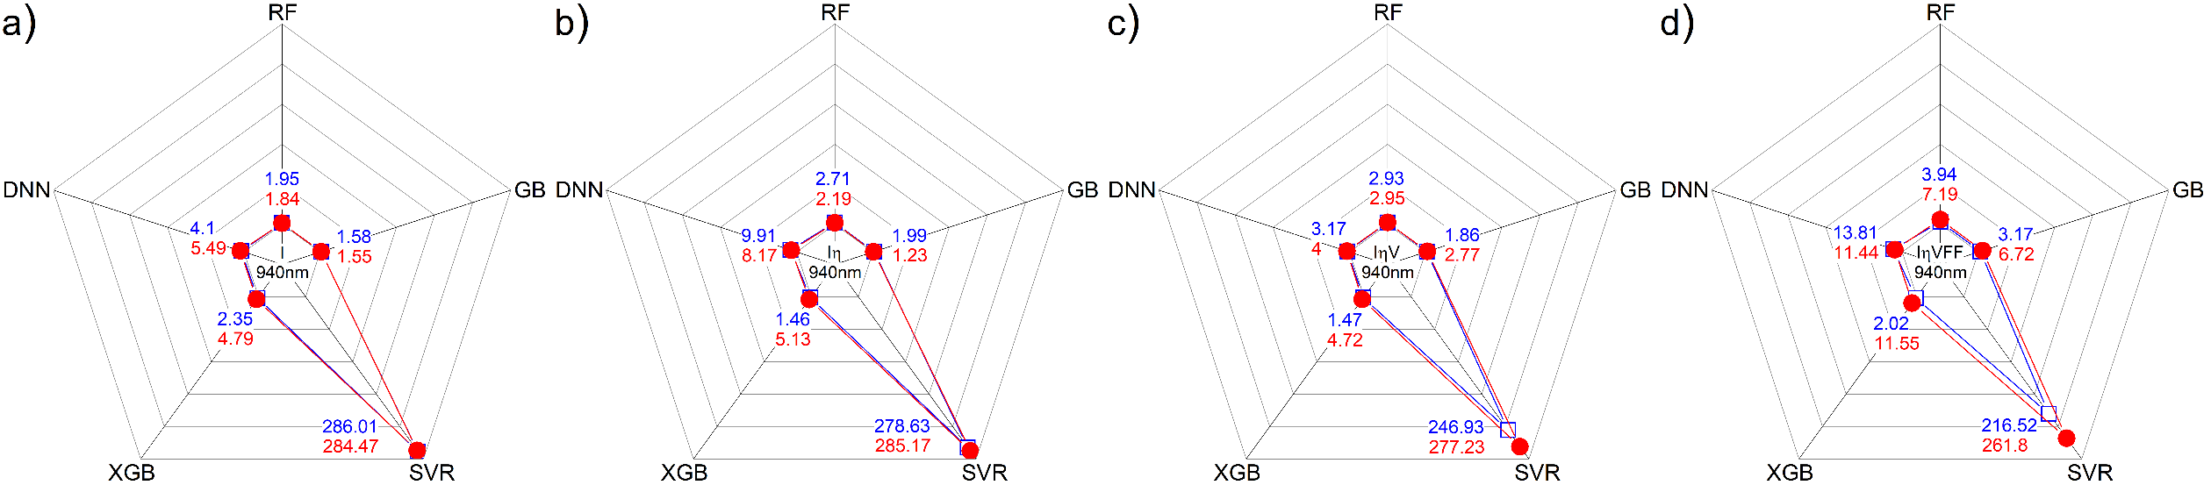

AM 1.5 [Full]

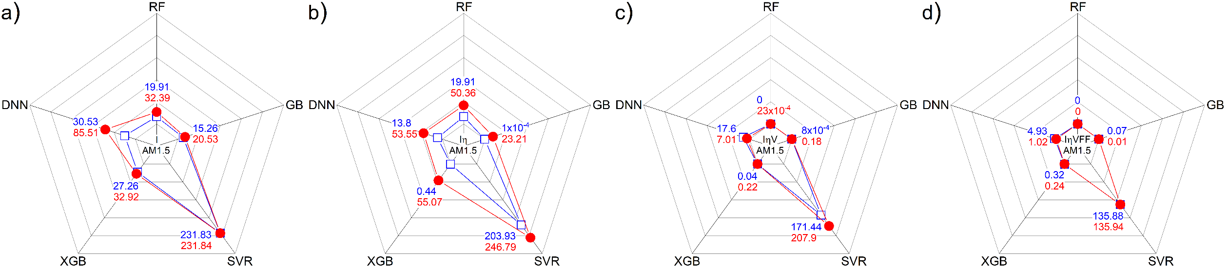

940 nm [Full]

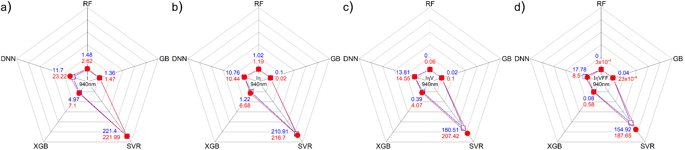

AM 1.5 [T_var]

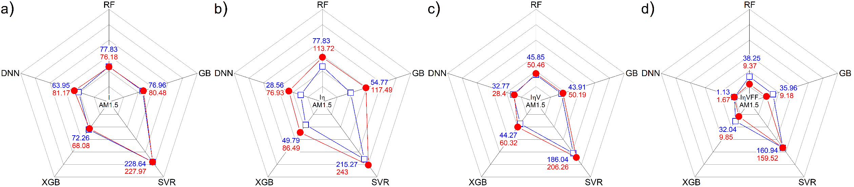

940 nm [T_var]

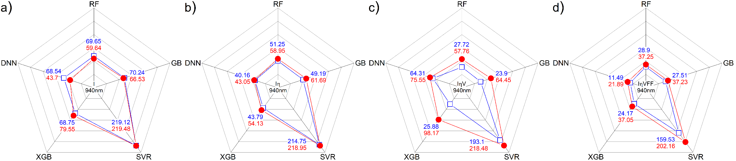

AM 1.5 [Train]

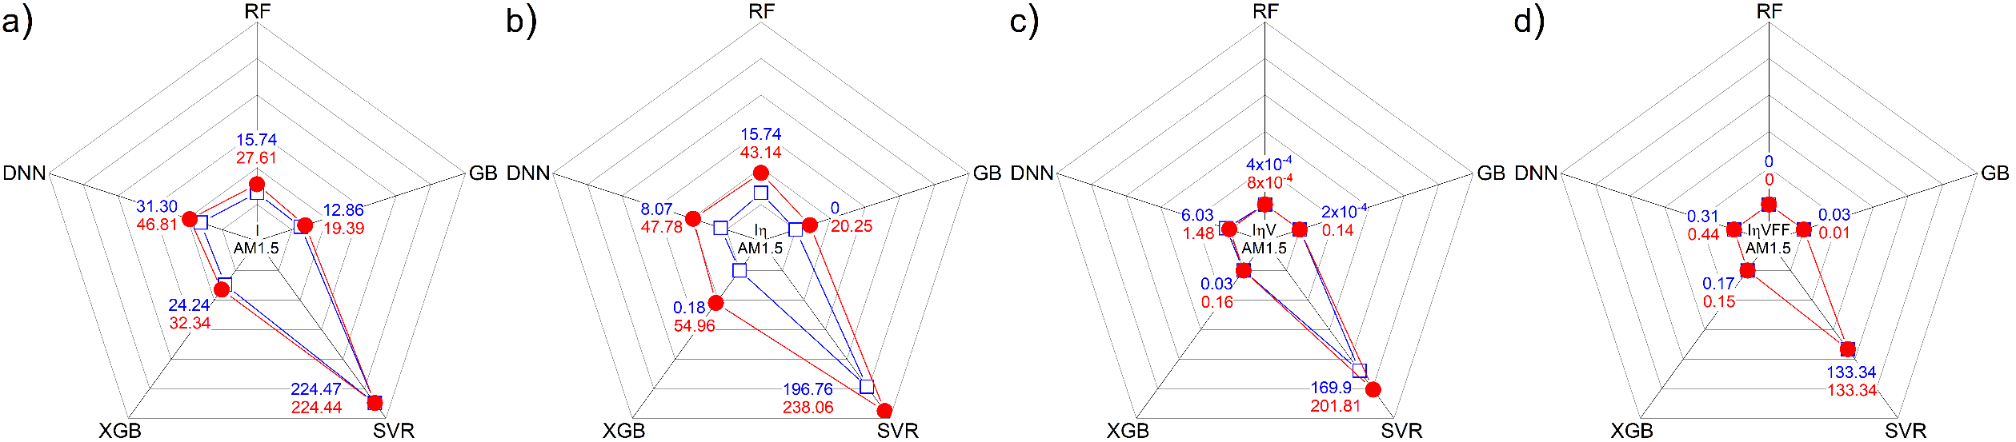

940 nm [Train]

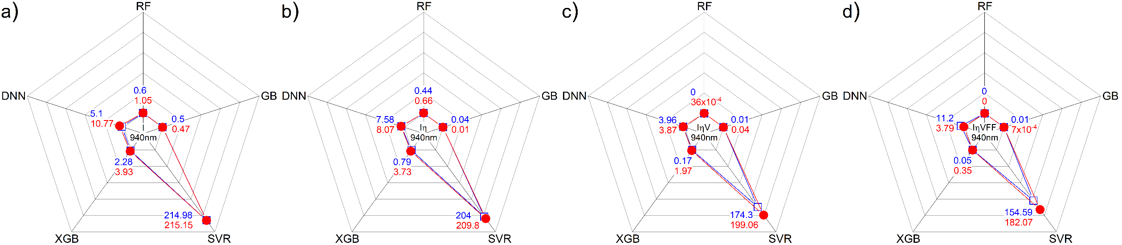

3) R2

[All_var]

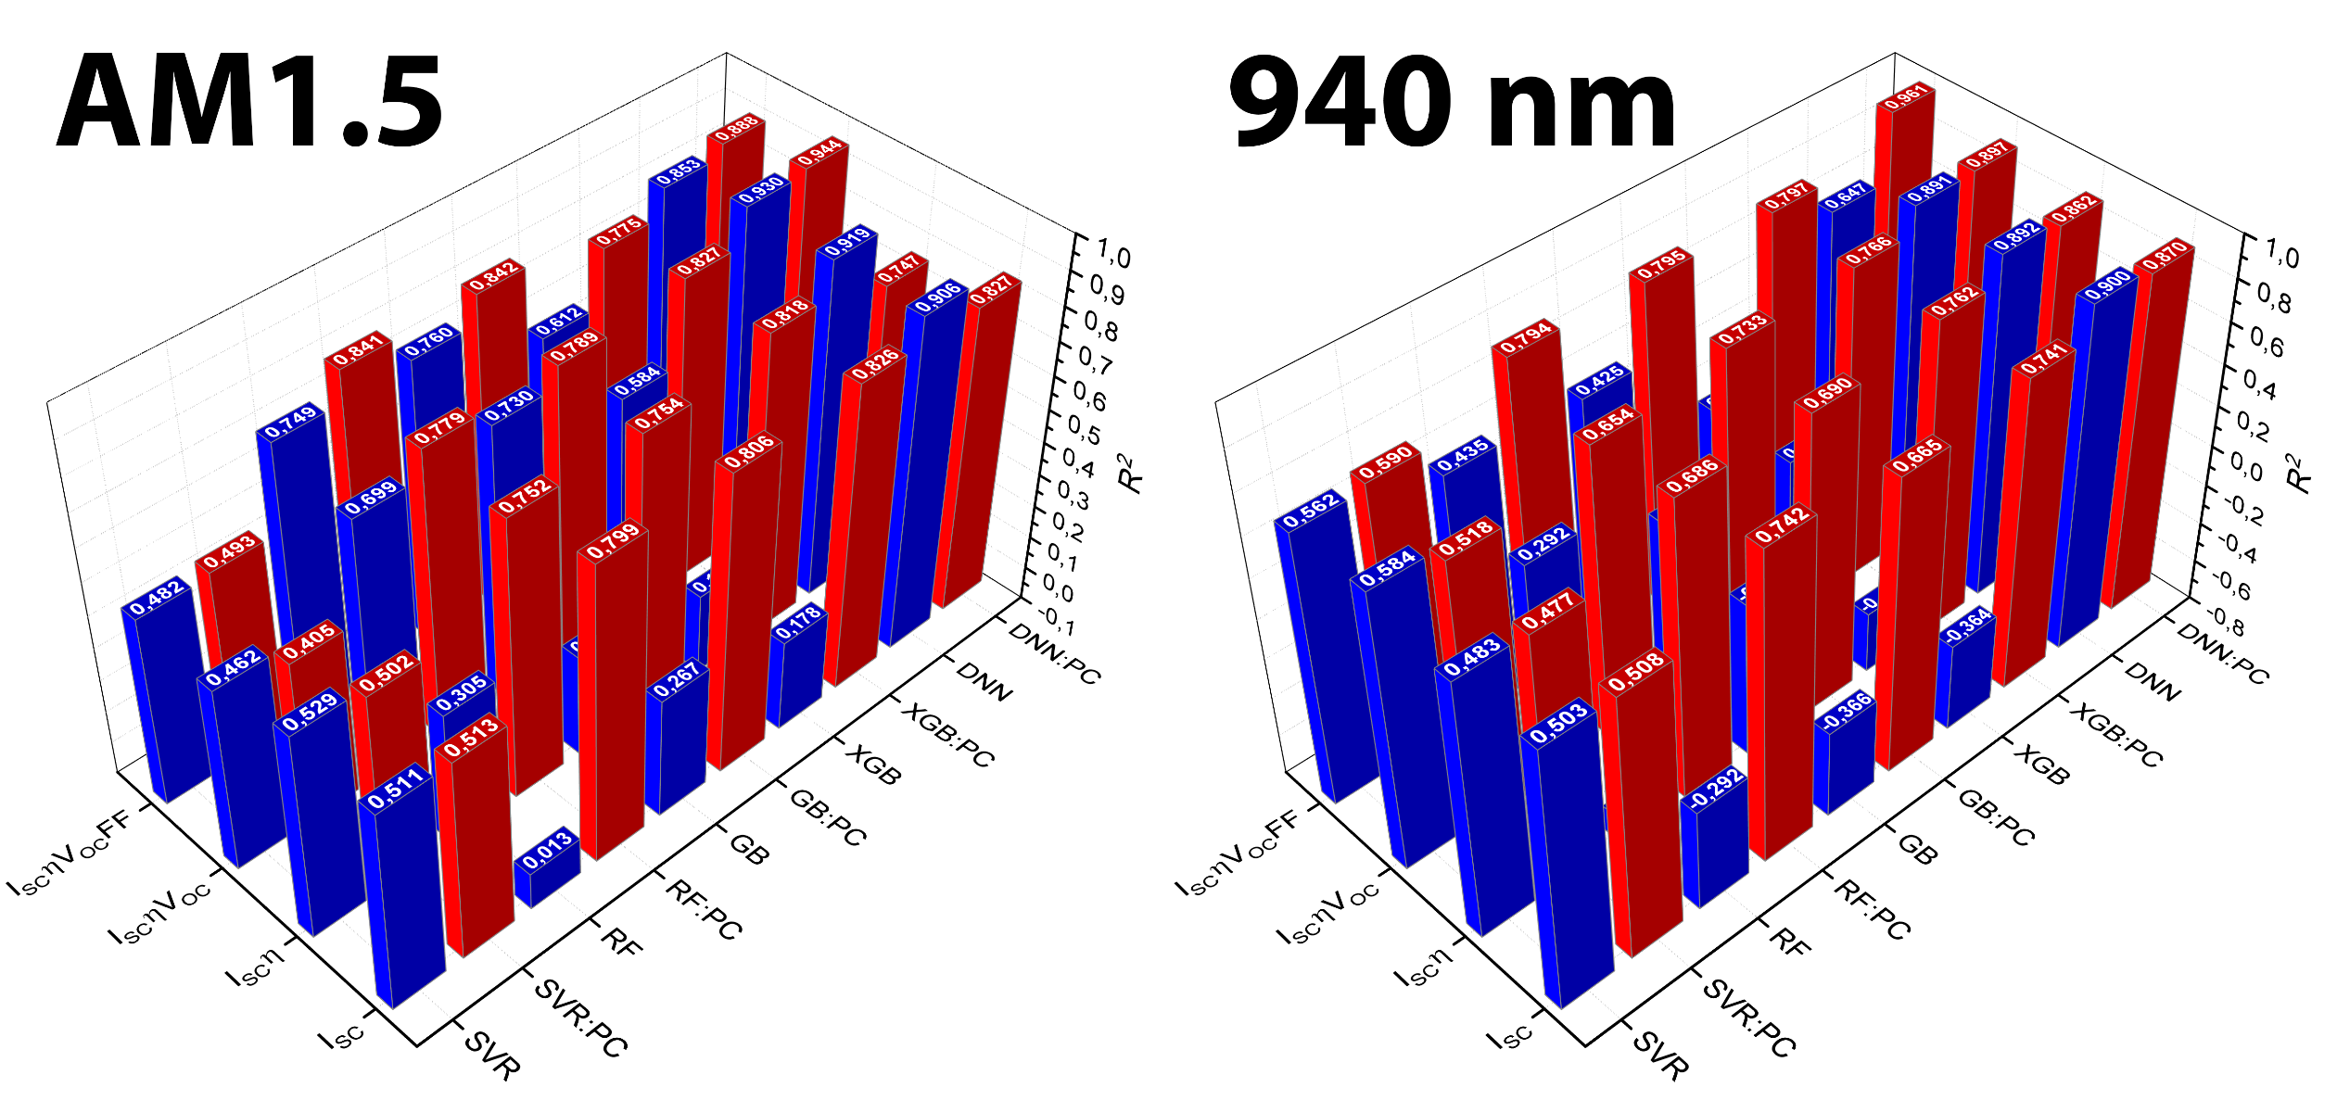

[B_var]

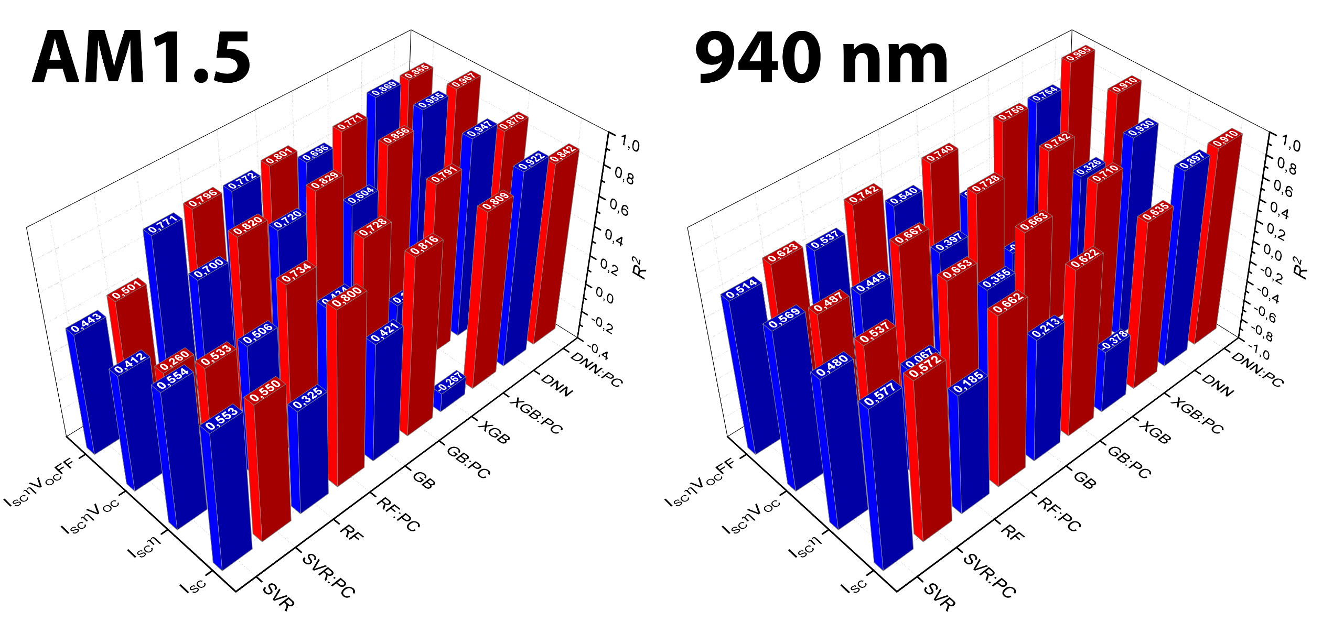

[Fe_var]

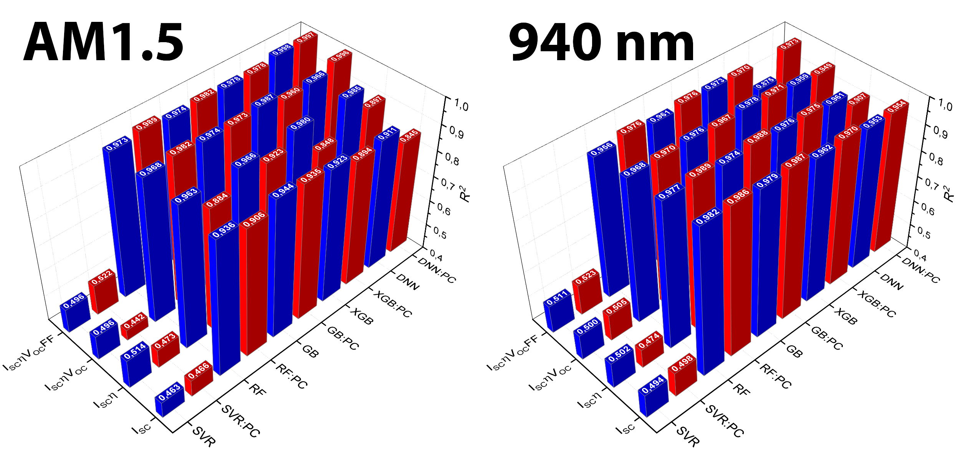

[Full]

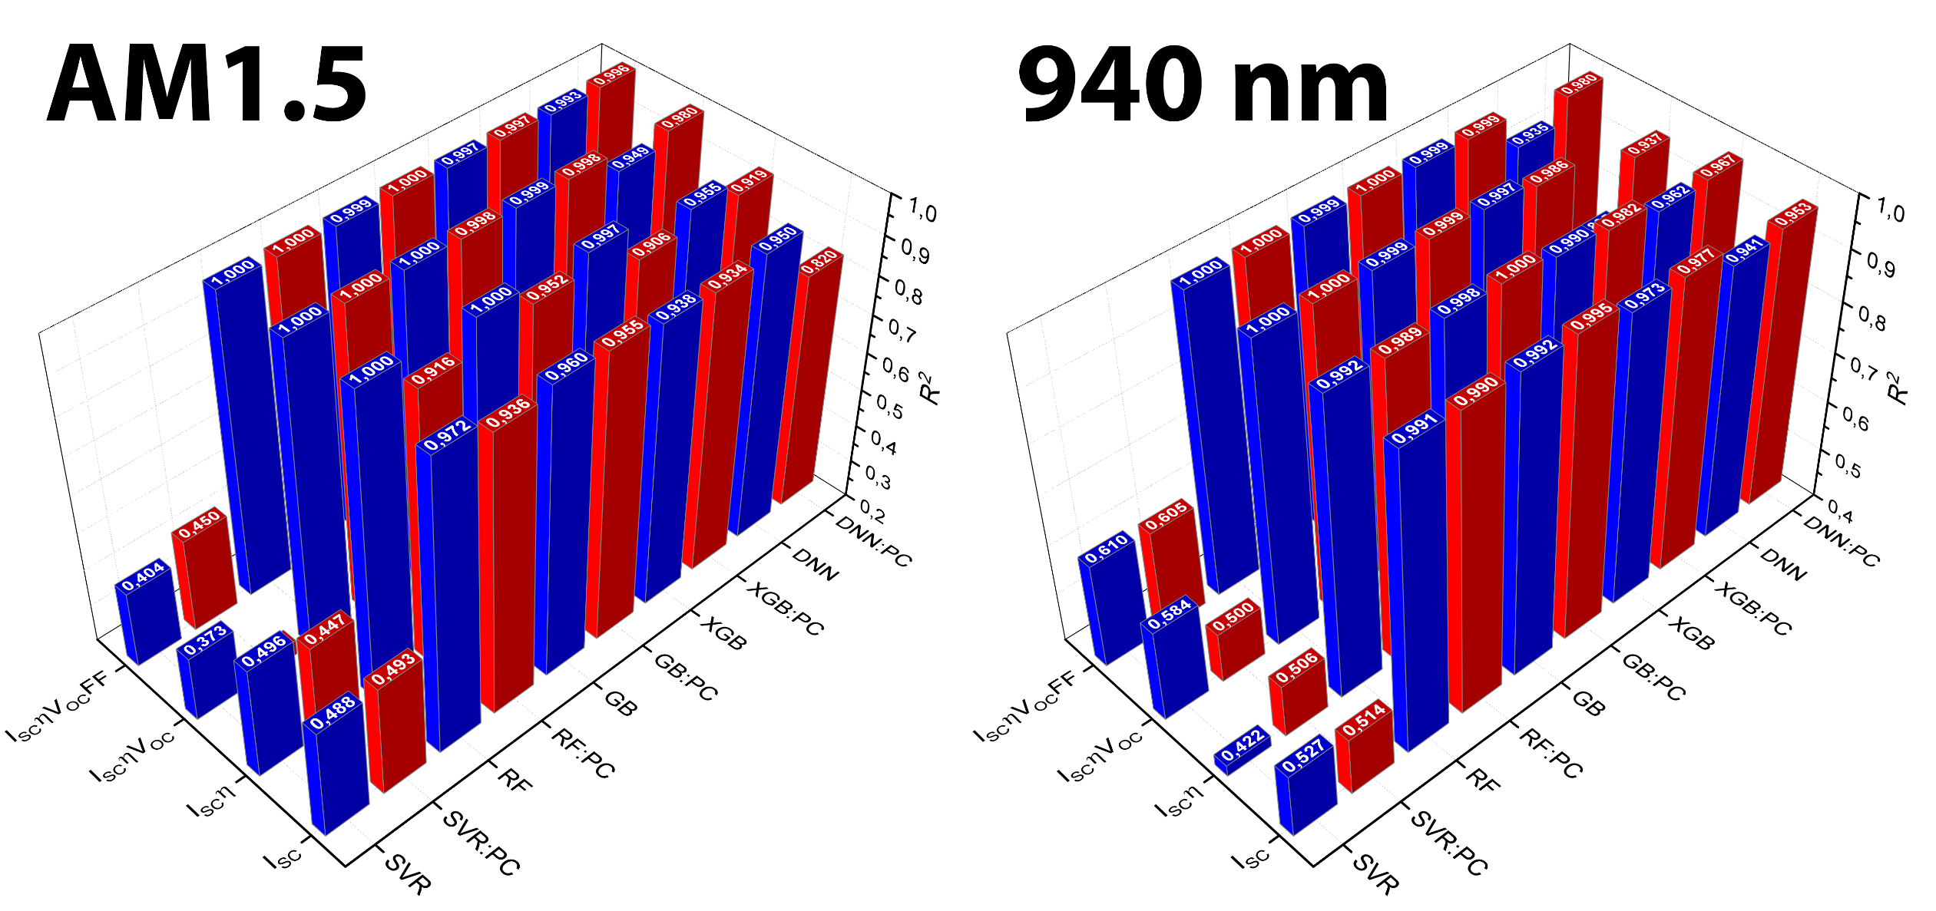

[T_var]

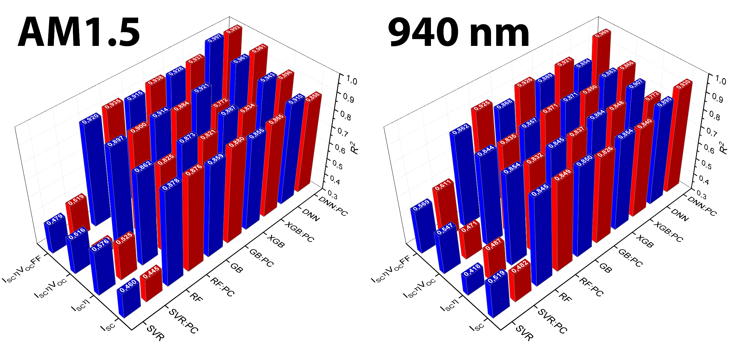

[Train]

